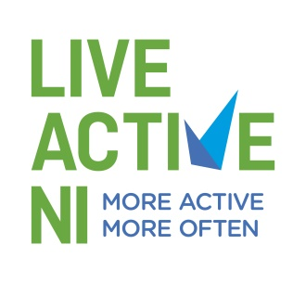

Appendix 1

Incident Record Form

Adult’s Name: _____________________________

Adult’s Address: ______________________________

______________________________

Date of Birth: ______________________________

Nature and details of allegation (including times and dates):

Description of any visible injuries:

Witness statement:

Action taken:

Remember:
- Keep questions to a minimum, obtain enough information to ensure you understand what is being said or communicated – you are reporting a concern, not investigating it.
- A clear distinction must be made between fact, opinion and conjecture and this must be clearly stated in the report.
- State the nature of the possible abuse – physical, sexual, emotional or neglect or any combination of these.
- Include a description of any physical marks (including the site) or of any visible bruising or injuries.
- Include the adult’s account of what has happened and how any bruising or injuries occurred. Let the child or young person tell you in his or her own way.
- Make sure relevant times and dates are included.
- Make a note of any organisation, social services personnel, police personnel or parents or relatives you spoke to; include their telephone numbers.
- Continue on separate sheet if necessary.
- This information is confidential.

Signature: ____________________________ Date ___________________________
(Disability Sport NI or Live Active NI Staff Member/Coach/Volunteer)

