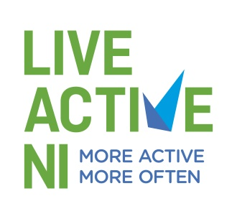

Appendix 1

Incident Record Form

Child or Young Person’s Name: _____________________________

Child or Young Person’s Address: _____________________________

_____________________________

Date of Birth: _____________________________

Nature and details of allegation (including times and dates):

Description of any visible injuries:

Witness statement:

Action taken:

Remember:
- Keep questions to a minimum, obtain enough information to ensure you understand what is being said or communicated – you are reporting a concern, not investigating it.
- A clear distinction must be made between fact, opinion and conjecture and this must be clearly stated in the report.
- State the nature of the possible abuse – physical, sexual, emotional or neglect or any combination of these.
- Include a description of any physical marks (including the site) or of any visible bruising or injuries.
- Include the child or young person’s account of what has happened and how any bruising or injuries occurred. Let the child or young person tell you in his or her own way.
- Make sure relevant times and dates are included.
- Make a note of any organisation, social services personnel, police personnel or parents or relatives you spoke to; include their telephone numbers.
- Continue on separate sheet if necessary.
- This information is confidential.

Signature: ____________________________ Date ___________________________
(Disability Sport NI or Live Active NI Staff Member/Coach/Volunteer)

